Generic Protocol Adapter Multiplexer (pam) user instructions.

# Summary:

The PAM allows a low bandwidth serial device (RS232 or RS485) to be connect to the main control bus of the PRO4 ROV. The PAM along with Cockpit, which needs to have an appropriate device configuration file installed, acts as a transparent interface for the connected device.

Both 12V and 24V pass through connections are available.

## PAM To ROV Wiring:

The PAM connects to the ROV through the 9-pin accessory port.

Accessory Port Specifications

PIN FUNCTION

1 Video -

2 Video +

3 24 VDC + (30 Watts*)

4 Aux + (APIC) Connects to tether pin 4 and control panel AUX port pin 7

5 Power Common (Ground)

6 Aux - (APIC) Connects to tether pin 6 and control panel AUX port pin 8

7 RS-485 -/A

8 RS-485 +/B

9 12 VDC + (30 Watts*)=

Attach the 9 pin whip to the 9 PinOUT side of the PAM board per the wiring diagram:

* Orange (GND) – 5 (GND)
* Gray (RS485-) – 7 (RS485-)
* Blue (RS485+) – 8 (RS485+)
* Brown (12V) – 9 (12V) (This line provides power to the PAM module)

|  |  |
| --- | --- |
|  |  |

[OPTIONALLY] Pin 3 can be connected to provide 24V Pass through.

## PAM To Device Wiring:

The device to be connected is hooked up the PinIN side of the connector.

Attach the wires from the RS485 device to the 9 PinIN side of the PAM board per the wiring diagram:

Pin 5 is ground

Pin 3 is 24 V (which must also be hooked up on the PinOUT side if being used.

Pin 12 is 12V

Pin 7&8 are the Comms pins.

RS-485 example:

* + Yellow (RS485+) – 7 (RS485+)
  + Violet (RS485-) – 8 (RS485-)

**NOTE: these pin designations are REVERSED from the 9PinOut usage.**

RS-232 example:

* + Yellow (Device RS232 TX) – 7 (PAM RS232 RX)
  + Violet (Device RS232 RX) – 8 (PAM RS232 TX)
  + NOTSHOWN (gnd) - 5 (gnd)

**NOTE that Tx/Rx designations are from the point of view of each side. So Pin 7 should be connected to the TX pin of the device, this is the device data output and the PAM device side input.**

|  |  |
| --- | --- |
|  |  |

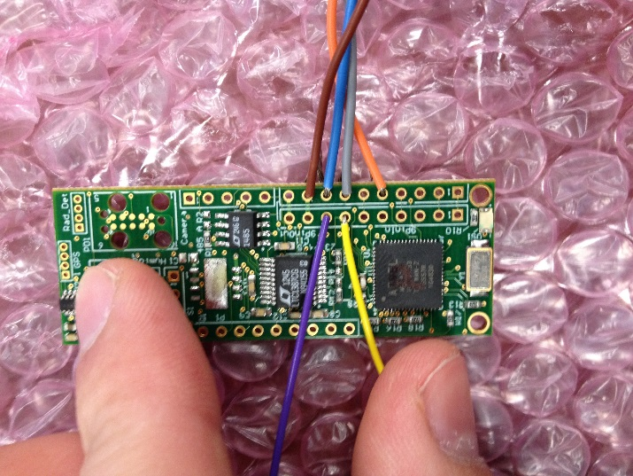

Power connection is dependent on the device connected, but again 12V and 24V are available.

## Device Configuration:

The baud rate and the choice of RS485 or RS232 can be configured using the vrDeviceConfiguration tool.

These settings are stored in EEPROM on the PAM.

**Typically the PAM will be factory configured for the appropriate customer use and vrDeviceConfiguration does NOT need to be used.**

However for basic usage:

1. Connect the PAM to the ROV and power on everything.
2. Run vrDeviceConfiguration.exe. It is in the same directory as vrCockpit (C:\Program Files (x86)\VideoRay\vrCockpit)
3. Once you have verified the PAM is receiving power, click the “?” button to enumerate the PAM.

|  |  |
| --- | --- |
|  |  |

1. The default setting for the PAM is a generic protocol adapter which should not be changed. Click the “ID” button to identify the PAM as such.

|  |  |
| --- | --- |
|  |  |

1. To set the PAM to be RS485 capable, click the dropdown menu next to “Device RS485” and select yes.

|  |  |
| --- | --- |
|  |  |

1. Press the Save Button (DISK ICON) to save the Accessory Device File for cockpit to use.
2. Finally click the download button (CHIP with ARROW ICON)

## Cockpit Configuration:

Cockpit requires an accessory device file to be installed to use the PAM.

The accessory device file informs Cockpit how to address the PAM (node ID) as well as other parameters. If the accessory device file is not installed cockpit will not communicate with the PAM and thus communication with the connected device is impossible.

**Accessory device files can be created using the vrDeviceConfiguration tool. See previous instructions. However, a factory configured device configuration file is typically provided with the PAM.**

Any factory configured device configuration files provided need to be installed into the C:\Users\VideoRay\AppData\Local\VideoRay\AccessoryDevices\ directory on the computer running cockpit.

The accessory device file is an xml file, with human readable field names

There are two fields which may require user modification, in which case a text editor can be used.

<PortName>

<SimpleName>COM2</SimpleName>

<FriendlyName>COM2</FriendlyName>

</PortName>

<BaudRate>9600</BaudRate>

The PortName field designates which serial port will be used to relay the data. This can be a real or virtual comm port. The BaudRate field sets the baud rate of the Relay port.

## Cockpit Diagnostics:

PAM and accessory device communications can be monitored using the communication diagnostics window. This is available by clicking the ***Maintance and Diagnostic*** button on the Launch bar and then pressing the ***Show communications diagnostic window*** button on the Service Bay screen.

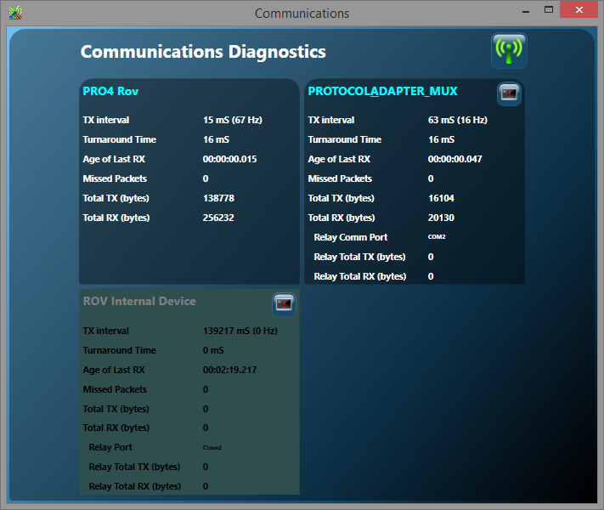

Each PAM in the system will have its own pane. Pressing the ***Show Terminal Window*** button on the individual pane will allow the actual data traffic to be monitored.